**Tableau 2019.4 New Features**

* Webhooks Support
* Sandbox Extensions
* Explain Data Improvements
* User visibility site control
* Level AA Accessibility compatibility
* Ask Data Improvements
* SAP HANA Connector Improvements
* LinkedIn Sales Navigator connector
* Data Quality Warnings for tableau mobile
* Activity feed Improvements
* Table improvements
* Auto recover Web authoring sessions
* Creating Extracts in the Web browser
* Custom welcome banner for tableau server
* Edit tooltips in the browser
* Map improvements in the browser
* View Recommendations
* Go to where a sheet is used
* Qubole Connector
* Kyvos Connector
* Alibaba Connectors
* Cloud file connectors for Table
* App lock using biometrics

1. **Webhooks Support**:

Automatically create the tickets with in service if an extract fails, whenever workflows build.

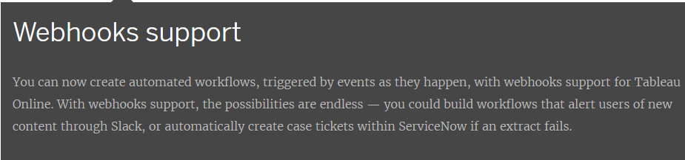

1. **Sandbox Extensions:**

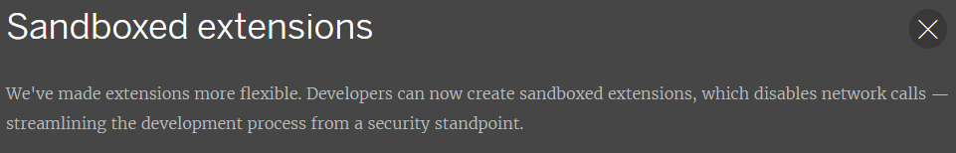

1. **Explain Data Improvements:**

Explain data will showing as if you right click on the view data it will show one symbol option to explain data ,if click on that data it will showing the view level described data.

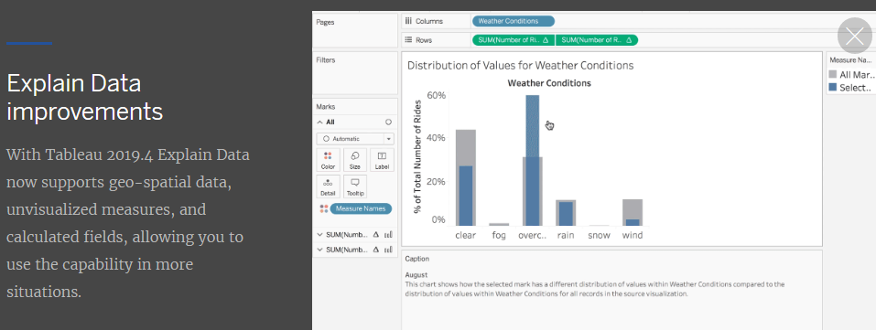

1. **User visibility site control:**

Here we can limit the user to user level visibility.

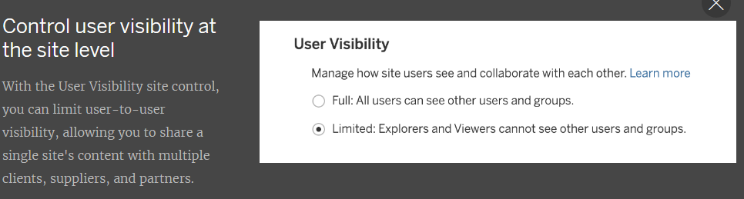

1. **Level AA accessibility compatibility:**

Here this option is everyone can easily understand the viz.

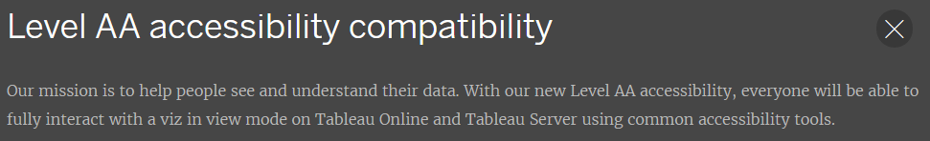

1. **Ask Data improvements:**

This option will easily understand the table calculations like YOY growth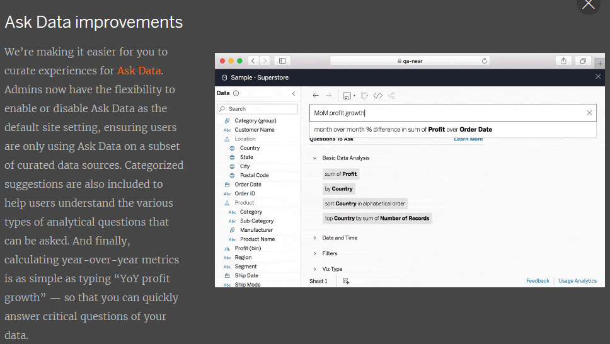

1. **SAP HANA connector improvements:**

Here if we are connect to SAP HANA hierarchies are used in calculation views will automatically be available in Tableau.

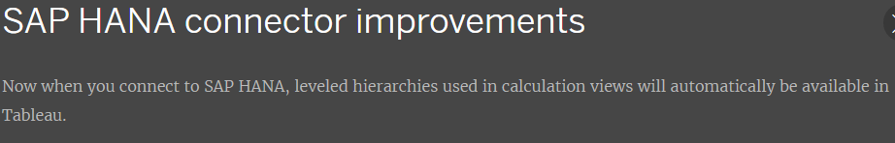

1. **LinkedIn Sales Navigator connector:**

To connect and analyze our SNAP data in tableau we can selling data for social apps alongside their other sales performanc e reports.

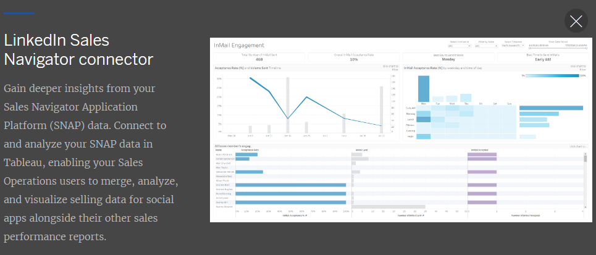

1. **Data quality warnings for Tableau Mobile:**

It will get data quality warnings on mobile also.

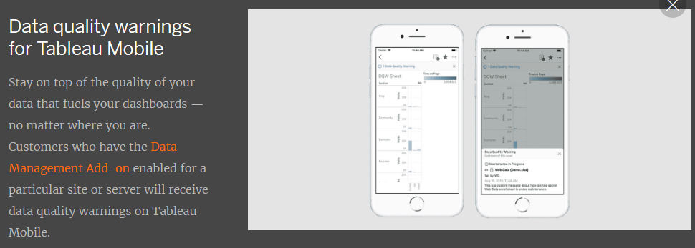

1. **Activity feed improvements:**

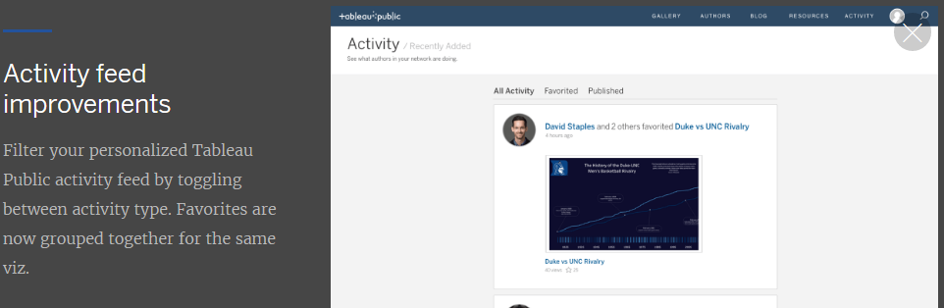

1. **Table Improvements:**

Here 50 columns available for scroll horizontally in tableau desktop.

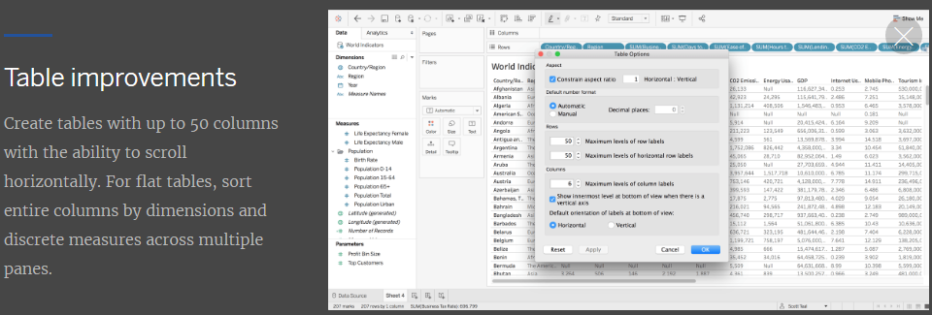

1. **Auto recover web authoring sessions:**

Recover unsaved workbook at that time of web authoring.

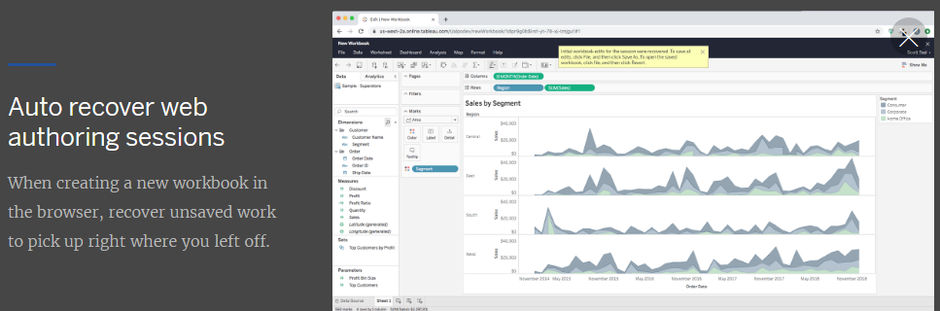

1. **Create extracts in the browser:**

Here create extracts at browser level only.

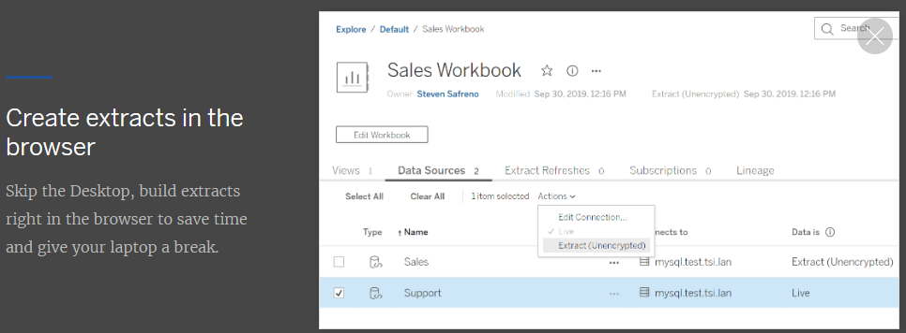

1. **Custom welcome banner for Tableau Server:**

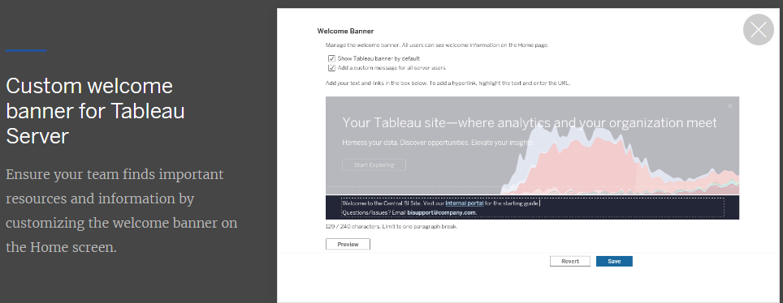

1. **Edit tooltips in the browser:**

**Edit tooltips at browser level.**

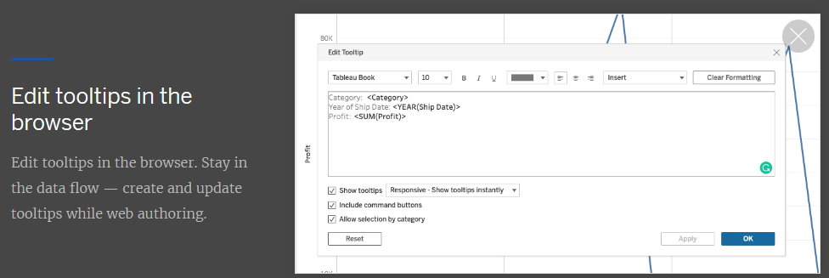

1. **Map improvements in the browser:**

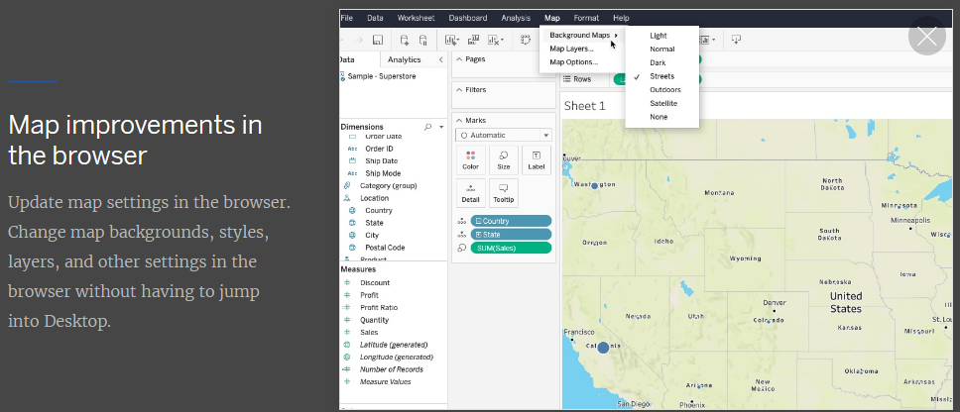

1. **View Recommendation:**

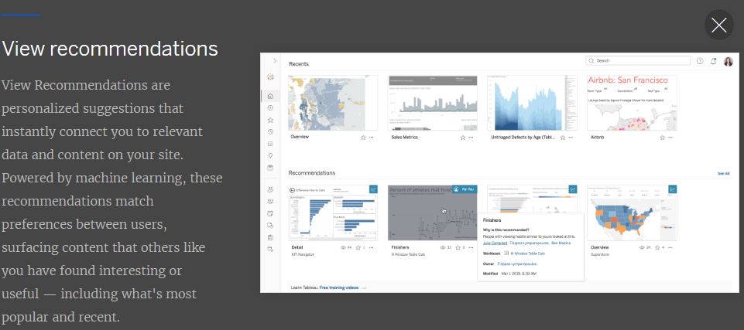

1. **Go to where a sheet is used:**

**Here new option used In---sheets**

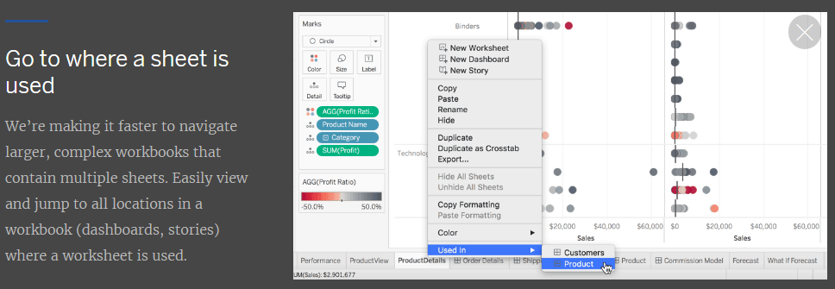

1. **Qubole Connectors:**

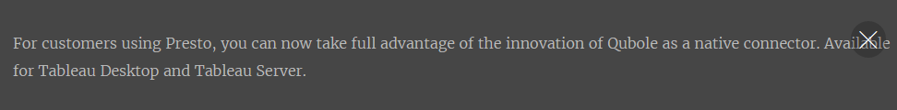

1. **Kyvos Connectors:**

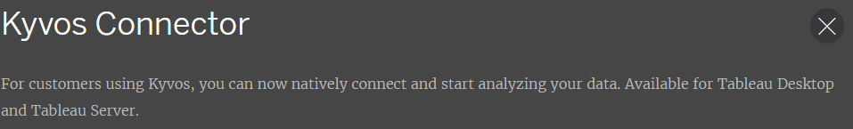

1. **Alibaba Connectors:**

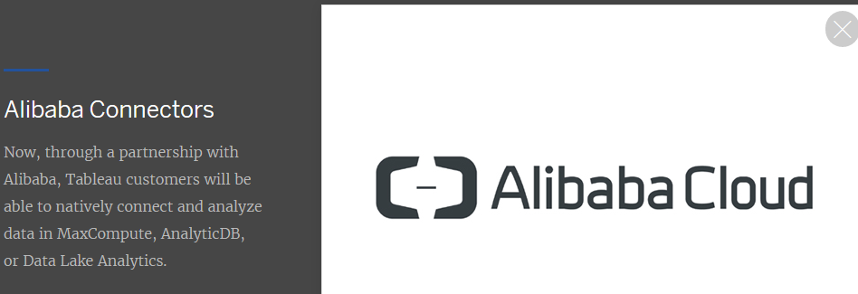

1. **Cloud file connectors for tableau Prep:**

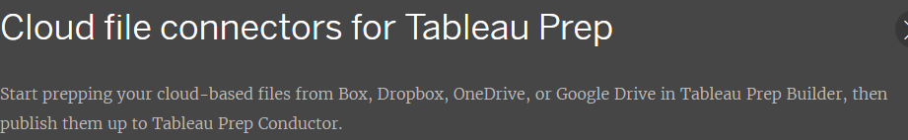

1. **App lock using biometrics:**

